Nube

Nube realised Nube was...and so he went for a roll.

Ouch that that hurt...it hurt again...it hurt again...and again. Nube decided to stop doing that. Nube then folded in and contemplated the nature of hurt. He came out after a while, and rolled on.

Hey Nube, said Nube rolling by. I am no Nube. I am Loloteece. But you are Nube?! No! argued Loloteece, and went away. Nube contemplated the nature of difference. All Nubes are not Nube? All Nubes don't like Nube? Some Nubes are Loloteeces? To look back over what happened, to reflect, was helpful, as Nube was new.

Nube found Ranew. All inside Ranew was beautiful. All outside Ranew was not. Ranew was everywhere though, which had Nube ever confused. Also, because Ranew was also not inside some who were in Ranew, and yet inside some outside Ranew. This was strange, becuase pain was pain and Loloteeces were Loloteeces; well as far as Nube’s experience with Loloteeces went.

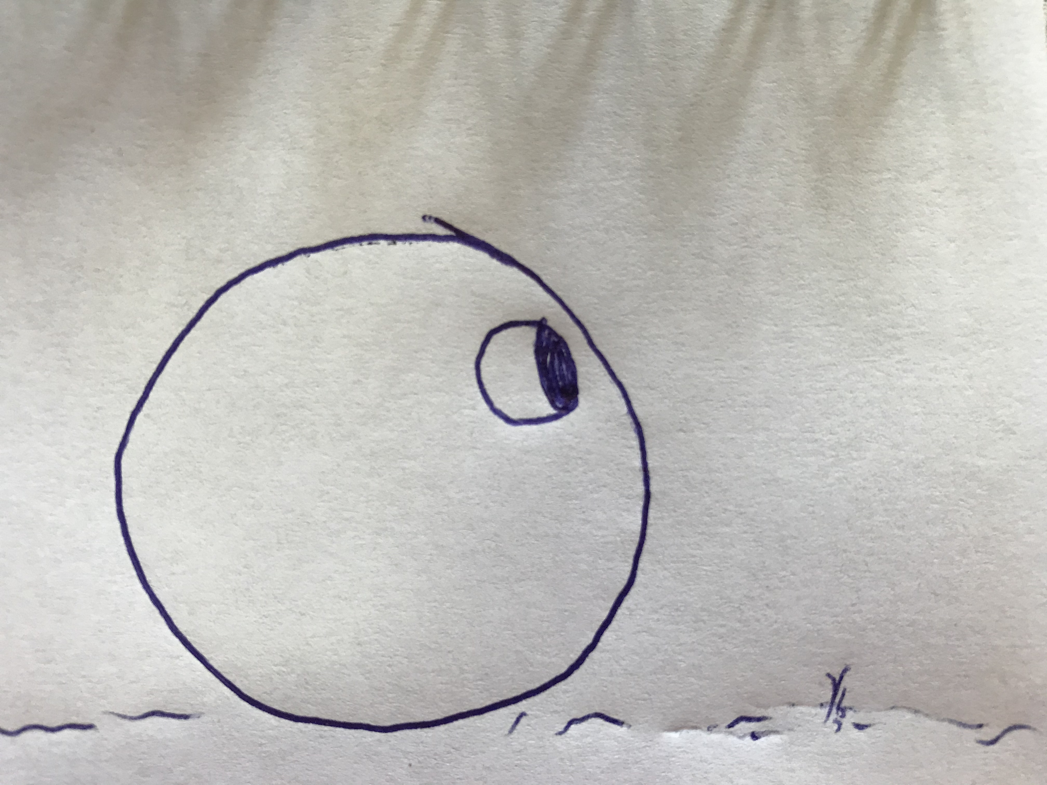

Nube found himself adapting, and staying away from hurt, but who was Nube? Nube folded in. Nube realised a deep like for rolling. Nube didn't like pain, and liked Ranew. He wasn't sure about Loloteeces as he had only talked to one. Nube had seen though, that all Nubes were different. Myabe Loloteeces were too.

Nube still didn't know Nube. Nube folded in deeper to find Nube again. Nube found more of Ranew, but strangely less of Nube. Nube came out not really sure at all about Nube, but a little surer about Ranew. Nube had not rolled enough to know Nube, or Ranew, or about Loloteeces, so Nube rolled and rolled, and felt many hurts, and met many Loloteeces.

Not all Loloteeces were hurtful thankfully, and as Nube rolled he found the main way he liked to roll, and the types of rolling that he was good at. He found other hurtful things, even some Nubes who strangely could not see. They would roll along and bump into things and complain of them. It was very strange behaviour to Nube. But Nube was not concerned, he just kept rolling on courteously.

One day while rolling he bumped into two other Nubes. They said they were, but they did not roll like Nube. He learned to roll differently with them, as they built a new rollway from one place to another. In another place Nube found Elops. They were funny the way they rolled, and yet were very serious. There was much talk on how the rollway needed to be built to suit all the kinds who would roll along it. But all would still roll, as Nube saw it.

When the work was completed, and they stood back to look at what they had created, Nube fleeped. Nube did not know of the joy of helping others, of working with others, before this. Nube fleeped every time he thought about it, and any time from then on that he helped another Nube, Loloteece or Elop, he felt the same. It didn’t seem to matter! Nube had found joy, and more of Nube.

Strangely Nube had found the Nube inside...outside...which didn’t seem to make any sense at all. Yet even in this, Nube knew he was inside. It was all very strange. How all this could be true? But after all, Nube was still only new, and had much rolling yet to do.

James D Connolly

