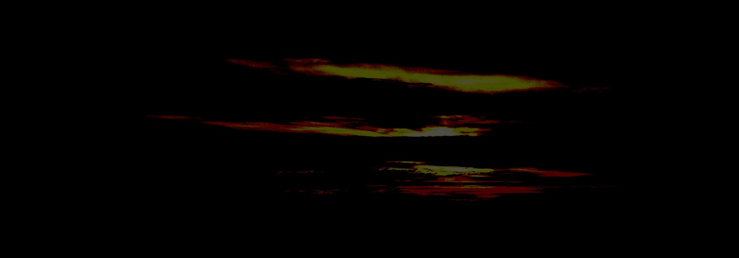

Seek only the truth; and the guidance of The Light.
And you may work this light within the shadows,
and in the very heart of darkness.
Have no expectation, none. Cast your life away.
And you may work this light within the shadows,
and in the very heart of darkness.
Speak your truth easily. Endeavour in all humility.
And you may work this light within the shadows,
and in the very heart of darkness.
Go with a courageous heart. With fire and joy.
And you may work this light within the shadows,
and in the very heart of darkness.

Only in the heart of love. Free from fear and control.
Only in the heart of faith. Free to roam and wander.

May you work this light within the shadows,
and in the very heart of darkness.

JDC

